DubSmart AI – Intelligent Audio & Video Dubbing System
A Project Based Learning Report Submitted in partial fulfilment of the requirements for the award of the degree

of

Bachelor of Technology
in The Department of Artificial Intelligence & Data Science
TEXT ANALYTICS with 23SDCS18A
Submitted by
2310080015: P. UmaBhavisha
2310080049: B. Nithesha
2310080064: N. Janusha

Under the guidance of
MANI KUMAR CHAKILAM


Department of Artificial Intelligence and Data Science
Koneru Lakshmaiah Education Foundation, Aziz Nagar
Aziz Nagar – 500075
Apr – 2026.
Abstract

DubSmart AI is an advanced artificial intelligence-driven system designed to automate the process of audio and video dubbing for multilingual content accessibility. With the exponential growth of digital media across platforms such as streaming services, online education portals, and social media, the demand for efficient and scalable dubbing solutions has increased significantly. Traditional dubbing methods rely heavily on human voice actors and manual synchronization, making them time-consuming, expensive, and difficult to scale for large volumes of content.
To address these challenges, DubSmart AI proposes an end-to-end automated pipeline that integrates key components of speech and language processing, including Speech-to-Text (STT), Neural Machine Translation (NMT), and Text-to-Speech (TTS). The system processes input Hindi-language videos by extracting audio, performing noise reduction, identifying speech segments using Voice Activity Detection (VAD), and distinguishing multiple speakers through speaker diarization. The extracted speech is then transcribed into text, translated into Telugu while preserving semantic meaning, and synthesized into natural-sounding speech.
A key contribution of this system is its ability to maintain speaker identity, temporal alignment, and conversational structure, ensuring that the dubbed output closely resembles the original content. The final synthesized audio is aligned with the video to produce a synchronized dubbed output. Experimental evaluation indicates that the system achieves approximately 85% transcription accuracy and generates intelligible and contextually relevant translated speech.
The proposed system demonstrates the feasibility of automating the dubbing process using artificial intelligence, significantly reducing manual effort, cost, and production time. It provides a scalable solution for multilingual content localization and has potential applications in media, education, entertainment, and accessibility domains.

- List of Figures
- Figure 1: End-to-End Pipeline Flow
- List of Tables
- Table 1: Functional Testing Results
- Table 2: Performance Evaluation Metrics

- Table of Contents
- Introduction
- Methodology
- Experiments
- Results
- Conclusion and Future Work
- Reference
DubSmart AI – Intelligent Audio & Video Dubbing System

Introduction
The rapid advancement of digital technology and the widespread availability of high-speed internet have led to an exponential increase in the consumption of video content across the globe. Platforms such as YouTube, OTT streaming services, online learning systems, and social media networks generate and distribute vast amounts of multimedia content daily. However, one of the most significant challenges in global content distribution is the language barrier, which limits accessibility for audiences who do not understand the source language.
Dubbing has traditionally been used as a solution to overcome this barrier by replacing the original audio with speech in a target language. However, conventional dubbing processes involve multiple stages, including script translation, voice recording by professional artists, audio editing, and synchronization with video. These processes require significant human effort, specialized infrastructure, and time, making them costly and inefficient for large-scale content production. Additionally, maintaining synchronization, speaker identity, and emotional expression remains a complex task even in manual workflows.
Recent advancements in Artificial Intelligence (AI), particularly in the fields of Natural Language Processing (NLP), Speech Processing, and Deep Learning, have opened new possibilities for automating the dubbing process. Technologies such as Automatic Speech Recognition (ASR), Neural Machine Translation (NMT), and Text-to-Speech (TTS) have reached a level of maturity where they can be integrated into end-to-end systems capable of performing complex language and speech transformations.
DubSmart AI is proposed as an intelligent, speaker-aware automated dubbing system that leverages these advancements to provide a scalable and efficient solution for multilingual video conversion. The system is designed to convert Hindi-language videos into Telugu-dubbed outputs by processing the input through a structured pipeline consisting of audio extraction, noise reduction, Voice Activity Detection (VAD), speaker diarization, speech-to-text conversion, translation, and speech synthesis.
One of the critical challenges addressed in this project is the preservation of speaker identity and temporal alignment. In multi-speaker scenarios, it is essential to correctly identify and separate speakers, assign appropriate synthesized voices, and ensure that the generated speech aligns with the original timing of the video. DubSmart AI addresses these challenges by incorporating speaker-aware processing and timestamp-based alignment mechanisms.
Furthermore, the system is designed to handle real-world scenarios, including noisy audio conditions and conversational speech patterns. By integrating robust preprocessing techniques such as noise filtering and VAD, the system improves transcription accuracy and overall output quality.
The primary objective of this project is to demonstrate the feasibility and effectiveness of an AI-driven dubbing system that reduces dependency on manual processes while maintaining acceptable levels of accuracy and quality. The proposed solution not only enhances accessibility for non-native audiences but also enables content creators and organizations to expand their reach to a global audience efficiently.
In conclusion, DubSmart AI represents a significant step toward the automation of multimedia localization. It highlights the potential of integrating multiple AI technologies into a unified pipeline and lays the foundation for future research in real-time dubbing, emotion-aware speech synthesis, and advanced video synchronization techniques.

METHODOLOGY
The DubSmart AI system follows a modular pipeline approach for processing and converting input video into a dubbed output.
a. System Pipeline
The overall workflow of the system is as follows:
Video Input → Audio Extraction → Noise Reduction → VAD → Speaker Diarization → Speech-to-Text → Text Segmentation → Translation → Text-to-Speech → Audio Alignment → Final Video Output

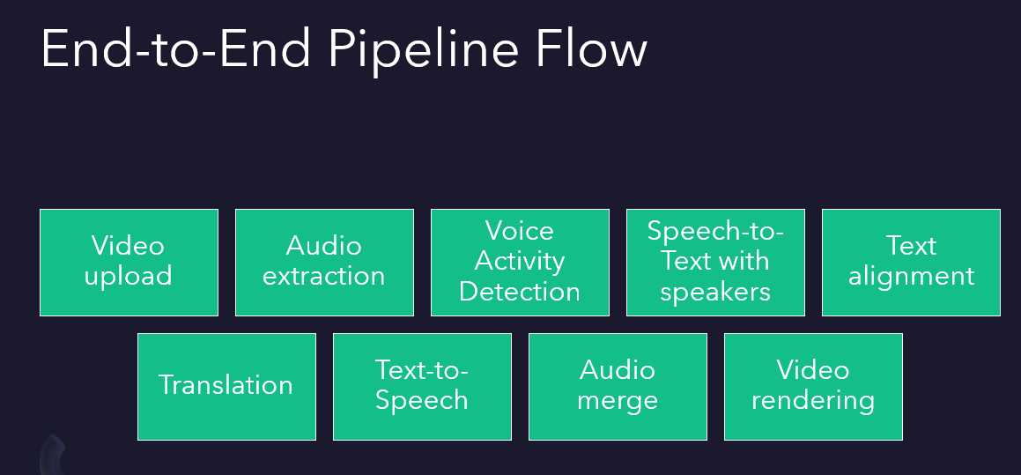
(Figure 1: End-to-End Pipeline Flow)

b. Module Description
1. Audio Extraction
The input video is processed using FFmpeg and MoviePy to extract audio in a standardized format (16kHz WAV), ensuring compatibility with speech processing models.

2. Noise Reduction & VAD
Silero VAD is used to remove silence and background noise, improving the quality of speech signals and enhancing transcription accuracy.
3. Speaker Diarization
The system identifies multiple speakers and segments the audio accordingly. Each segment is tagged with speaker identity for accurate dubbing.
4. Speech-to-Text (STT)
Using AssemblyAI or Whisper, the system converts speech into timestamped text transcripts.
5. Translation
The transcribed Hindi text is translated into Telugu using neural machine translation models while preserving semantic meaning.
6. Text-to-Speech (TTS)
The translated text is converted into speech using gTTS, generating natural-sounding Telugu audio.
7. Audio Alignment and Mixing
The generated speech segments are aligned with original timestamps and merged into the video using FFmpeg.

EXPERIMENTS
The system was tested using multiple Hindi-language video samples with durations up to 60 seconds. These samples included variations in speaker count, speech clarity, and background noise.
Dataset Characteristics
- Language: Hindi
- Output Language: Telugu
- Duration: ≤ 60 seconds
- Type: Conversational and single-speaker videos
Evaluation Setup
- Transcription accuracy evaluated manually
- Translation quality verified based on semantic correctness
- Audio output tested using user feedback
The experiments focused on evaluating system performance in real-world scenarios, including noisy audio and multi-speaker conversations.

RESULTS
The DubSmart AI system demonstrated effective performance across multiple stages of the pipeline.

  - Functional Testing
Test Case | Expected Result | Actual Result | Status
Video Upload | Accept valid file | Successful | Pass
STT | Accurate transcript | ~85% accuracy | Pass
Translation | Meaning preserved | ~85% accuracy | Pass
TTS | Clear speech output | Good clarity | Pass
Final Output | Dubbed video | Proper synchronization | Pass
  - Performance Metrics

Parameter | Value
Max Video Length | 60 sec
Avg Processing Time | 20 – 40 sec
Trascription Accuracy | ~85%
Translation Accuracy | ~80%

Observations
- The system successfully generated synchronized dubbed videos
- Speaker-aware processing improved dialogue clarity
- Noise handling improved transcription performance

CONCLUSION and FUTURE WORK

DubSmart AI presents an efficient and scalable solution for automated video dubbing using advanced AI technologies. By integrating speech recognition, translation, and speech synthesis into a unified pipeline, the system significantly reduces manual effort, time, and cost associated with traditional dubbing methods. The experimental results demonstrate that the system achieves reliable performance in transcription accuracy, translation quality, and synchronization. This highlights the potential of AI in transforming media localization and making digital content accessible to a global audience.

Future Work

Real-time dubbing system

Emotion-aware speech synthesis

Advanced lip-sync using video models

Improved speaker voice cloning

Support for multiple languages

References
[1] OpenAI Whisper – Speech Recognition
[2] AssemblyAI Documentation
[3] Silero VAD Github
[4] FFmpeg Documentation
[5] NeuralMachine Translation Research Papers

